***C PROGRAMS***

**1.C program to perform all arithmetic operations**

#include <stdio.h>

int main(void) {

double num1, num2;

printf("Enter two numbers: ");

scanf("%lf %lf", &num1, &num2);

printf("Sum: %lf\n", num1 + num2);

printf("Difference: %lf\n", num1 - num2);

printf("Product: %lf\n", num1 * num2);

printf("Quotient: %lf\n", num1 / num2);

return 0;

}

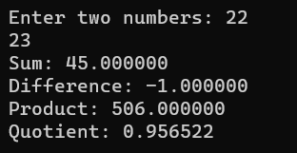

**2. C program to find area of a triangle if base and height are given**

#include <stdio.h>

int main(void) {

double base, height, area;

printf("Enter the base of the triangle: ");

scanf("%lf", &base);

printf("Enter the height of the triangle: ");

scanf("%lf", &height);

area = (base * height) / 2;

printf("The area of the triangle is: %lf\n", area);

return 0;

}

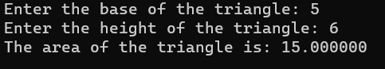

**3. C program to find all angles of a triangle if two angles are given.**

#include <stdio.h>

int main(void) {

double angle1, angle2, angle3;

printf("Enter the first angle of the triangle: ");

scanf("%lf", &angle1);

printf("Enter the second angle of the triangle: ");

scanf("%lf", &angle2);

angle3 = 180 - angle1 - angle2;

printf("The third angle of the triangle is: %lf\n", angle3);

return 0;

}

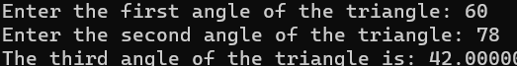

**4. C program to convert days in to years, weeks and days.**

#include <stdio.h>

int main(void) {

int days, years, weeks, remainingDays;

printf("Enter the number of days: ");

scanf("%d", &days);

years = days / 365;

weeks = (days % 365) / 7;

remainingDays = (days % 365) % 7;

printf("Years: %d\n", years);

printf("Weeks: %d\n", weeks);

printf("Days: %d\n", remainingDays);

return 0;

}

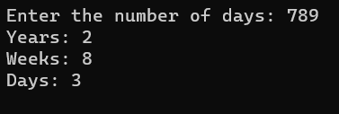

**5. C program to find power and square root of any number.**

// C program for the above approach

#include <math.h>

#include <stdio.h>

// Function to find the square-root of N

double findSQRT(double N) { return sqrt(N); }

// Driver Code

int main()

{

// Given number

int N = 12;

// Function call

printf("%f ", findSQRT(N));

return 0;

}

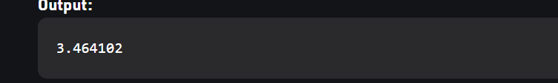

**6. C program to calculate total, average and percentage and grades of five subjects.**

#include <stdio.h>

int main()

{

double sub1, sub2, sub3, sub4, sub5; double total, average, percentage;

char grade;

printf("Enter marks of five subjects: ");

scanf("%lf%lf%lf%lf%lf", &sub1, &sub2, &sub3, &sub4, &sub5);

total = sub1 + sub2 + sub3 + sub4 + sub5;

average = total / 5;

percentage = (total / 500) * 100;

if (percentage >= 90)

grade = 'A';

else if (percentage >= 80 && percentage < 90)

grade = 'B';

else if (percentage >= 70 && percentage < 80)

grade = 'C';

else if (percentage >= 60 && percentage < 70)

grade = 'D';

else

grade = 'F';

printf("Total marks: %lf\n", total);

printf("Average marks: %lf\n", average);

printf("Percentage: %lf%%\n", percentage);

printf("Grade: %c\n", grade);

return 0;

}

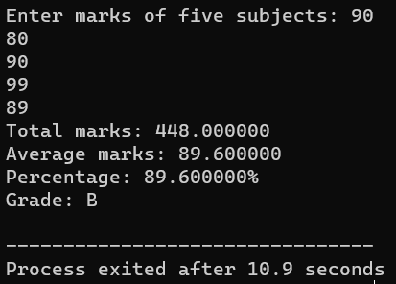

**7. C program to check Least Significant Bit (LSB) and MSB of a**

**number using bitwise operator.**

#include<stdio.h>

Int main ()

{

int num,lsb,msb;

printf("Enter a number: ");

scanf("%d", &num);

lsb = num & 1;

msb = num >> 31;

printf("Least Significant Bit: %d\n", lsb);

printf("Most Significant Bit: %d\n", msb);

return 0;

}

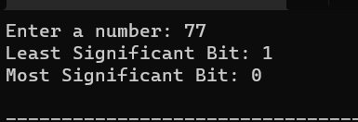

**8. C program to swap two numbers USING 3RD VARIABLE AND**

**WITHOUT 3RD VARIABLE.**

#include<stdio.h>

Int main ()

{

Int num1,num2,temp;

printf("Enter two numbers: ");

scanf("%d%d", &num1, &num2);

temp = num1;

num1 = num2;

num2 = temp;

printf("Swapped numbers using 3rd variable: %d %d\n", num1, num2);

num1 = num1 + num2;

num2 = num1 - num2;

num1 = num1 - num2;

printf("Swapped numbers without 3rd variable: %d %d\n", num1, num2);

return 0;

}

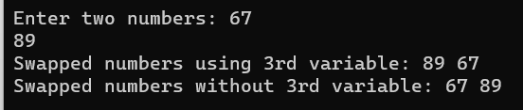

**9. C program to find maximum between three numbers using**

**conditional operator AND Ternary Operator.**

#include<stdio.h>

Int main ()

{

Int num1,num2,num3;

printf("Enter three numbers: ");

scanf("%d%d%d", &num1, &num2, &num3);

int max = (num1 > num2) ? num1 : num2;

max = (max > num3) ? max : num3;

printf("Maximum using conditional operator: %d\n", max);

max = num1 > num2 ? (num1 > num3 ? num1 : num3) : (num2 > num3 ? num2 : num3);

printf("Maximum using ternary operator: %d\n", max);

return 0;

}

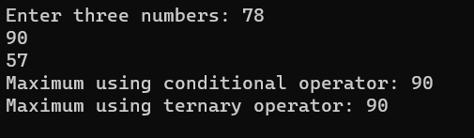

**10. C program to check alphabet, digit or special character using**

**Conditional operator.**

#include<stdio.h>

Int main ()

{

Char ch;

printf("Enter a character: ");

scanf("%c", &ch);

if (ch >= 'A' && ch <= 'Z' || ch >= 'a' && ch <= 'z')

printf("The character is an alphabet.\n");

else if (ch >= '0' && ch <= '9')

printf("The character is a digit.\n");

else

printf("The character is a special character.\n");

return 0;

}



**11. C program to calculate total electricity bill**

#include<stdio.h>

int main()

{

int unit;

double bill;

printf("Enter number of units consumed: ");

scanf("%d", &units);

if (units <= 100)

bill = units * 0.50;

else if (units <= 200)

bill = 50 + (units - 100) * 0.75;

else if (units <= 300)

bill = 125 + (units - 200) * 1.20;

else

bill = 325 + (units - 300) * 1.50;

printf("Total electricity bill: %.2lf\n", bill);

return 0;

}



**12. C program to create Simple Calculator AND Days of week**

**using switch case.**

#include <stdio.h>

int main() {

char op;

double first, second;

printf("Enter an operator (+, -, *, /): ");

scanf("%c", &op);

printf("Enter two operands: ");

scanf("%lf %lf", &first, &second);

switch (op) {

case '+':

printf("%.1lf + %.1lf = %.1lf", first, second, first + second);

break;

case '-':

printf("%.1lf - %.1lf = %.1lf", first, second, first - second);

break;

case '*':

printf("%.1lf * %.1lf = %.1lf", first, second, first * second);

break;

case '/':

printf("%.1lf / %.1lf = %.1lf", first, second, first / second);

break;

// operator doesn't match any case constant

default:

printf("Error! operator is not correct");

}

return 0;

}

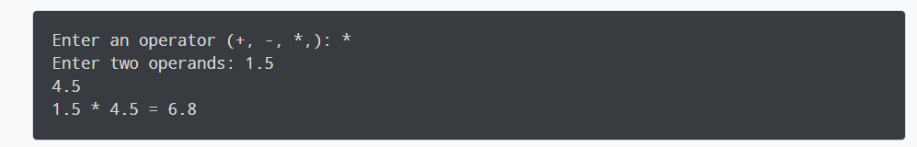

**13. C program to check vowel or consonant using switch case.**

#include <stdio.h>

int main()

{

char c;

printf("Enter a character: ");

scanf("%c", &c);

switch (c)

{

case 'a':

case 'e':

case 'i':

case 'o':

case 'u':

case 'A':

case 'E':

case 'I':

case 'O':

case 'U':

printf("%c is a vowel.\n", c);

break;

default:

printf("%c is a consonant.\n", c);

break;

}

return 0;

}

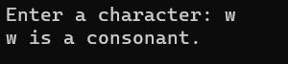

**14. C program to check positive negative or zero using switch**

**case.**

#include <stdio.h>

int main()

{

int num;

printf("Enter a number: ");

scanf("%d", &num);

switch (num > 0)

{

case 1:

printf("The number is positive.\n");

break;

case 0:

switch (num < 0)

{

case 1:

printf("The number is negative.\n");

break;

case 0:

printf("The number is zero.\n");

break;

}

break;

}

return 0;

**}**

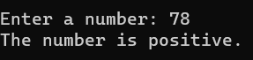

**15. C program to check whether a triangle is Equilateral, Isosceles**

**or Scalene.**

include <stdio.h>

int main()

{

int side1, side2, side3

printf("Enter three sides of a triangle: ");

scanf("%d%d%d", &side1, &side2, &side3);

if (side1 == side2 && side2 == side3)

printf("The triangle is Equilateral.\n");

else if (side1 == side2 || side2 == side3 || side1 == side3)

printf("The triangle is Isosceles.\n");

else

printf("The triangle is Scalene.\n");

return 0;

**}**

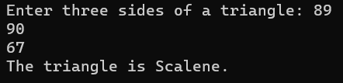

**16. C program to print all natural numbers AND sum of it from 1**

**to n.**

#include <stdio.h>

int main()

{

int n, i, sum = 0;

printf("Enter a number: ");

scanf("%d", &n);

printf("All natural numbers from 1 to %d: ", n);

for (i = 1; i <= n; i++)

{

printf("%d ", i);

sum += i;

}

printf("\n");

printf("Sum of all natural numbers from 1 to %d: %d\n", n, sum);

return 0;

}



**17. C program to print all even numbers AND sum of it from 1 to n**

#include <stdio.h>

int main()

{

int n, i, sum = 0;

printf("Enter a number: ");

scanf("%d", &n);

printf("All even numbers from 1 to %d: ", n);

for (i = 2; i <= n; i += 2)

{

printf("%d ", i);

sum += i;

}

printf("\n");

printf("Sum of all even numbers from 1 to %d: %d\n", n, sum);

return 0;

}



**18. C program to print multiplication table of a number.**

#include <stdio.h>

int main()

{

int n, i;

printf("Enter a number: ");

scanf("%d", &n);

for (i = 1; i <= 10; i++)

{

printf("%d * %d = %d\n", n, i, n * i);

}

return 0;

}

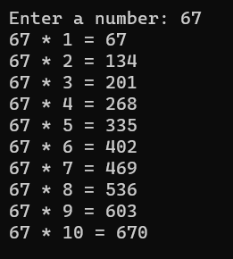

**19. C program to calculate factorial of a** number**.**

include <stdio.h>

int main()

{

int n, i;

long long factorial = 1;

printf("Enter an integer: ");

scanf("%d", &n);

if (n < 0)

printf("Error! Factorial of a negative number doesn't exist.");

# else

{

for (i = 1; i <= n; ++i)

{

factorial *= i;

}

printf("Factorial of %d = %lld", n, factorial);

}

return 0;

}

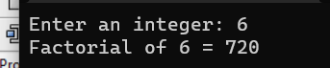

**20. C program to check whether a number is palindrome or not.**

**#**include <stdio.h>

int main()

{

int n, reversedN = 0, remainder, originalN;

printf("Enter an integer: ");

scanf("%d", &n);

originalN = n;

// reversed integer is stored in reversedN

while (n != 0)

{

remainder = n % 10;

reversedN = reversedN * 10 + remainder;

n /= 10;

}

// palindrome if originalN and reversedN are equal

if (originalN == reversedN)

printf("%d is a palindrome.", originalN);

else

printf("%d is not a palindrome.", originalN);

return 0;

}



**21. C program to count frequency of digits in a given number.**



**22. C program to find HCF(GCD) AND LCM of two numbers.**

#include <stdio.h>

int main()

{

int n1, n2;

int hcf, lcm;

printf("Enter two positive integers: ");

scanf("%d %d", &n1, &n2);

// maximum number between n1 and n2 is stored in hcf

hcf = (n1 > n2) ? n1 : n2;

while (1)

{

if (hcf % n1 == 0 && hcf % n2 == 0)

{

printf("The LCM of %d and %d is %d.\n", n1, n2, hcf);

break;

}

++hcf;

}

// minimum number between n1 and n2 is stored in lcm

lcm = (n1 < n2) ? n1 : n2;

while (1)

{

if (lcm % n1 == 0 && lcm % n2 == 0)

{

printf("The HCF of %d and %d is %d.", n1, n2, lcm);

break;

}

++lcm;

}

return 0;

}

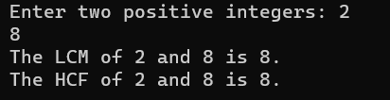

**23. C program to print all prime numbers between 1 to n.**

#include <stdio.h>

int main()

{

int n, i, flag;

printf("Enter a positive integer: ");

scanf("%d", &n);

printf("Prime numbers between 1 and %d are: ", n);

for (i = 2; i <= n; ++i)

{

flag = 1;

for (int j = 2; j <= i / 2; ++j)

{

if (i % j == 0)

{

flag = 0;

break;

}

}

if (flag == 1)

printf("%d ", i);

}

return 0;

}

**24. C program to print all Strong Numbers between 1 to n**

#include <stdio.h>

int main()

{

int n, i, j, sum, fact, originalN;

printf("Enter a positive integer: ");

scanf("%d", &n);

printf("Strong numbers between 1 and %d are: ", n);

for (i = 1; i <= n; ++i)

{

originalN = i;

sum = 0;

while (i > 0)

{

fact = 1;

int lastDigit = i % 10;

for (j = 1; j <= lastDigit; ++j)

fact *= j;

sum += fact;

i /= 10;

}

if (sum == originalN)

printf("%d ", originalN);

i = originalN;

}

return 0;

}



**25. C program to print Fibonacci series up to n terms.**

#include <stdio.h>

int main()

{

int i, n, t1 = 0, t2 = 1, nextTerm;

printf("Enter the number of terms: ");

scanf("%d", &n);

printf("Fibonacci Series: ");

for (i = 1; i <= n; ++i)

{

printf("%d, ", t1);

nextTerm = t1 + t2;

t1 = t2;

t2 = nextTerm;

}

return 0;

}



**26. C program to print Armstrong numbers from 1 to n AND**

**Check a given number is Armstrong numbers or not.**

#include <stdio.h>

int main()

{

int n, i, originalN, remainder, result;

// Print Armstrong numbers from 1 to n

printf("Enter the upper limit: ");

scanf("%d", &n);

printf("Armstrong numbers between 1 and %d are: ", n);

for (i = 1; i <= n; ++i)

{

originalN = i;

result = 0;

while (originalN != 0)

{

remainder = originalN % 10;

result += remainder * remainder * remainder;

originalN /= 10;

}

if (result == i)

printf("%d ", i);

}

// Check if a given number is an Armstrong number or not

int num;

printf("\nEnter a number to check if it is an Armstrong number: ");

scanf("%d", &num);

originalN = num;

result = 0;

while (originalN != 0)

{

remainder = originalN % 10;

result += remainder * remainder * remainder;

originalN /= 10;

}

if (result == num)

printf("%d is an Armstrong number.", num);

else

printf("%d is not an Armstrong number.", num);

return 0;

}

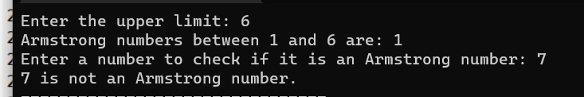

**27. C program to print all Perfect numbers between 1 to n AND**

**Check a given number is Perfect numbers or not.**

#include <stdio.h>

int main()

{

int n, i, sum;

// Print all Perfect numbers between 1 to n

printf("Enter the upper limit: ");

scanf("%d", &n);

printf("Perfect numbers between 1 and %d are: ", n);

for (i = 1; i <= n; ++i)

{

sum = 0;

for (int j = 1; j < i; ++j)

{

if (i % j == 0)

sum += j;

}

if (sum == i)

printf("%d ", i);

}

// Check if a given number is a Perfect number or not

int num;

printf("\nEnter a number to check if it is a Perfect number: ");

scanf("%d", &num);

sum = 0;

for (i = 1; i < num; ++i)

{

if (num % i == 0)

sum += i;

}

if (sum == num)

printf("%d is a Perfect number.", num);

else

printf("%d is not a Perfect number.", num);

return 0;

}

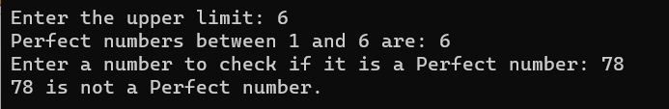

**28. C program to find power of any number using for loop.**

#include <stdio.h>

int main()

{

int base, exponent;

long long result = 1;

printf("Enter base and exponent: ");

scanf("%d %d", &base, &exponent);

for (int i = 1; i <= exponent; ++i)

{

result *= base;

}

printf("%d ^ %d = %lld", base, exponent, result);

return 0;

}

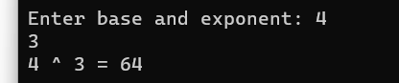

**29. C program to print ASCII values of all characters.**

#include <stdio.h>

int main()

{

char c;

printf("Enter a character: ");

scanf("%c", &c);

printf("ASCII value of %c = %d", c, c);

return 0;

}



**30. C program to print Pascal triangle up to n rows.**

#include <stdio.h>

int main()

{

int rows, coef = 1, space, i, j;

printf("Enter number of rows: ");

scanf("%d", &rows);

for (i = 0; i < rows; i++)

{

for (space = 1; space <= rows - i; ++space)

printf(" ");

for (j = 0; j <= i; j++)

{

if (j == 0 || i == 0)

coef = 1;

else

coef = coef * (i - j + 1) / j;

printf("%4d", coef);

}

printf("\n");

}

return 0;

}

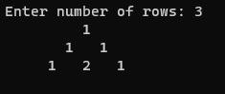

**31. C program to find sum of all elements of array.**

#include <stdio.h>

int main()

{

int size, i, sum = 0;

int arr[100];

printf("Enter size of the array: ");

scanf("%d", &size);

printf("Enter elements of the array: ");

for (i = 0; i < size; ++i)

{

scanf("%d", &arr[i]);

sum += arr[i];

}

printf("Sum of all elements of array = %d", sum);

return 0;

}

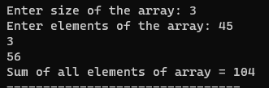

**32. C program to copy one array to another array.**

#include <stdio.h>

int main()

{

int size, i;

int source[100], target[100];

printf("Enter size of the array: ");

scanf("%d", &size);

printf("Enter elements of the source array: ");

for (i = 0; i < size; ++i)

{

scanf("%d", &source[i]);

}

// Copying elements of source array to target array

for (i = 0; i < size; ++i)

{

target[i] = source[i];

}

printf("Elements of target array: ");

for (i = 0; i < size; ++i)

{

printf("%d ", target[i]);

}

return 0;

}

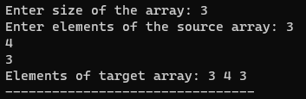

**33. C program to insert an element in array at specified position.**

#include <stdio.h>

int main()

{

int size, i, pos, element;

int arr[100];

printf("Enter size of the array: ");

scanf("%d", &size);

printf("Enter elements of the array: ");

for (i = 0; i < size; ++i)

{

scanf("%d", &arr[i]);

}

printf("Enter the element to be inserted: ");

scanf("%d", &element);

printf("Enter the position where the element is to be inserted: ");

scanf("%d", &pos);

// Shift elements of arr[pos...size-1] right by 1

for (i = size - 1; i >= pos; --i)

{

arr[i + 1] = arr[i];

}

// Insert element at given position

arr[pos] = element;

printf("Array after inserting element at given position:\n");

for (i = 0; i < size + 1; ++i)

{

printf("%d ", arr[i]);

}

return 0;

}

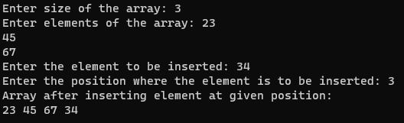

**34. C program to delete an element in array at specified position.**

#include <stdio.h>

int main()

{

int size, i, pos;

int arr[100];

printf("Enter size of the array: ");

scanf("%d", &size);

printf("Enter elements of the array: ");

for (i = 0; i < size; ++i)

{

scanf("%d", &arr[i]);

}

printf("Enter the position where the element is to be deleted: ");

scanf("%d", &pos);

// Shift elements of arr[pos+1...size-1] left by 1

for (i = pos; i < size - 1; ++i)

{

arr[i] = arr[i + 1];

}

printf("Array after deleting element at given position:\n");

for (i = 0; i < size - 1; ++i)

{

printf("%d ", arr[i]);

}

return 0;

}

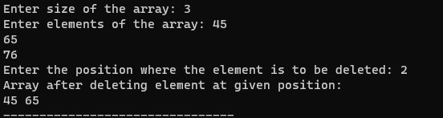

**35. C program to search element in array using Linear Search.**

#include <stdio.h>

int main()

{

int size, i, element, found = 0;

int arr[100];

printf("Enter size of the array: ");

scanf("%d", &size);

printf("Enter elements of the array: ");

for (i = 0; i < size; ++i)

{

scanf("%d", &arr[i]);

}

printf("Enter the element to be searched: ");

scanf("%d", &element);

for (i = 0; i < size; ++i)

{

if (arr[i] == element)

{

found = 1;

printf("Element %d found at position %d\n", element, i + 1);

break;

}

}

if (found == 0)

printf("Element %d not found in the array\n", element);

return 0;

}

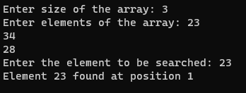

**36. C program to find second largest number and Sorting Using**

**Bubble sort in an array.**

#include <stdio.h>

int main()

{

int size, i, j, temp;

int arr[100];

printf("Enter size of the array: ");

scanf("%d", &size);

printf("Enter elements of the array: ");

for (i = 0; i < size; ++i)

{

scanf("%d", &arr[i]);

}

// Find second largest number

int max1 = 0, max2 = 0;

for (i = 0; i < size; ++i)

{

if (arr[i] > max1)

{

max2 = max1;

max1 = arr[i];

}

else if (arr[i] > max2 && arr[i] < max1)

{

max2 = arr[i];

}

}

printf("Second largest number = %d\n", max2);

// Sort the array using Bubble sort

for (i = 0; i < size - 1; ++i)

{

for (j = 0; j < size - i - 1; ++j)

{

if (arr[j] > arr[j + 1])

{

temp = arr[j];

arr[j] = arr[j + 1];

arr[j + 1] = temp;

}

}

}

printf("Array after sorting:\n");

for (i = 0; i < size; ++i)

{

printf("%d ", arr[i]);

}

return 0;

}

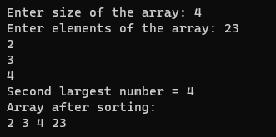

**37. C program to count total number of duplicate elements in an**

**array.**

#include <stdio.h>

int main()

{

int size, i, j, count = 0;

int arr[100];

printf("Enter size of the array: ");

scanf("%d", &size);

printf("Enter elements of the array: ");

for (i = 0; i < size; ++i)

{

scanf("%d", &arr[i]);

}

for (i = 0; i < size; ++i)

{

for (j = i + 1; j < size; ++j)

{

if (arr[i] == arr[j])

{

++count;

break;

}

}

}

printf("Total number of duplicate elements in the array = %d", count);

return 0;

}

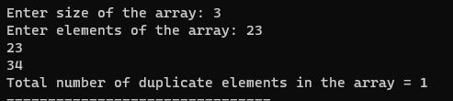

**38. C program to perform scalar matrix multiplication.**

#include <stdio.h>

#define SIZE 3 // Maximum size of the array

int main()

{

int A[SIZE][SIZE];

int num, row, col;

/* Input elements in matrix from user */

printf("Enter elements in matrix of size %dx%d: \n", SIZE, SIZE);

for(row=0; row<SIZE; row++)

{

for(col=0; col<SIZE; col++)

{

scanf("%d", &A[row][col]);

}

}

/* Input multiplier from user */

printf("Enter any number to multiply with matrix A: ");

scanf("%d", &num);

/* Perform scalar multiplication of matrix */

for(row=0; row<SIZE; row++)

{

for(col=0; col<SIZE; col++)

{

/* (cAij) = c . Aij */

A[row][col] = num * A[row][col];

}

}

/* Print result of scalar multiplication of matrix */

printf("\nResultant matrix c.A = \n");

for(row=0; row<SIZE; row++)

{

for(col=0; col<SIZE; col++)

{

printf("%d ", A[row][col]);

}

printf("\n");

}

**return 0;**

**}**

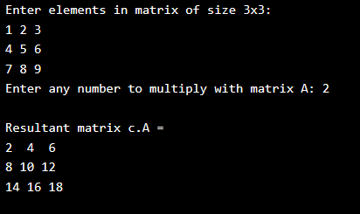

**39. C program to find sum of main diagonal elements of a matrix.**

#include <stdio.h>

int main()

{

int rows, cols, i, j;

int matrix[100][100];

int sum = 0;

printf("Enter number of rows: ");

scanf("%d", &rows);

printf("Enter number of columns: ");

scanf("%d", &cols);

printf("Enter elements of the matrix:\n");

for (i = 0; i < rows; ++i)

{

for (j = 0; j < cols; ++j)

{

scanf("%d", &matrix[i][j]);

}

}

for (i = 0; i < rows; ++i)

{

for (j = 0; j < cols; ++j)

{

if (i == j)

sum += matrix[i][j];

}

}

printf("Sum of main diagonal elements = %d", sum);

return 0;

}

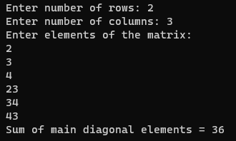

**40. C program to check sparse AND transpose matrix.**

#include <stdio.h>

int main()

{

int rows, cols, i, j;

int matrix[100][100];

printf("Enter number of rows: ");

scanf("%d", &rows);

printf("Enter number of columns: ");

scanf("%d", &cols);

printf("Enter elements of the matrix:\n");

for (i = 0; i < rows; ++i)

{

for (j = 0; j < cols; ++j)

{

scanf("%d", &matrix[i][j]);

}

}

// Check if matrix is sparse

int count = 0;

for (i = 0; i < rows; ++i)

{

for (j = 0; j < cols; ++j)

{

if (matrix[i][j] == 0)

++count;

}

}

if (count > (rows * cols) / 2)

printf("Matrix is sparse\n");

else

printf("Matrix is not sparse\n");

// Find transpose of matrix

printf("Transpose of the matrix:\n");

for (i = 0; i < rows; ++i)

{

for (j = 0; j < cols; ++j)

{

printf("%d ", matrix[j][i]);

}

printf("\n");

}

return 0;

}

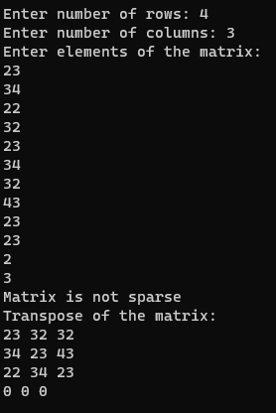

**41. C program to check whether a matrix is Identity matrix or not.**

**#include<stdio.h>**

int main()

{

int i, j, rows, columns, a[10][10], Flag = 1;

printf("\n Please Enter Number of rows and columns : ");

scanf("%d %d", &i, &j);

printf("\n Please Enter the Matrix Elements \n");

for(rows = 0; rows < i; rows++)

{

for(columns = 0; columns < j; columns++)

{

scanf("%d", &a[rows][columns]);

}

}

for(rows = 0; rows < i; rows++)

{

for(columns = 0; columns < j; columns++)

{

if(a[rows][columns] != 1 && a[columns][rows] != 0)

{

Flag = 0;

break;

}

}

}

if(Flag == 1)

{

printf("\n The Matrix that you entered is an Identity Matrix ");

}

else

{

printf("\n The Matrix that you entered is Not an Identity Matrix ");

}

return 0;

}

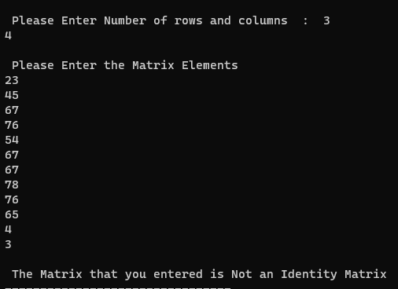

**42. C program to merge two sorted array in ascending order.**

#include <stdio.h>

int main() {

//Declaring the size of arrays

int s1, s2, s3;

printf("\n Enter the size of 1st array ");

scanf("%d", & s1);

printf("\n Enter the size of 2nd array ");

scanf("%d", & s2);

s3 = s1 + s2;

printf("\n Enter the elements of 1st array\n");

// Declaring the array

int arr1[s1], arr2[s2], arr3[s3];

//Initialising the array

for (int i = 0; i < s1; i++) {

scanf("%d", & arr1[i]);

arr3[i] = arr1[i];

}

int k = s1;

printf("\nEnter the elements of 2nd array \n");

for (int i = 0; i < s2; i++) //Array Initialised

{

scanf("%d", & arr2[i]);

arr3[k] = arr3[i];

k++;

}

printf("\nThe merged array before sorting : \n\t");

for (int i = 0; i < s3; i++)

printf("%d ", arr3[i]); //Print the merged array before sorting

printf("\n The merged array after sorting\n\t");

for (int i = 0; i < s3; i++) //Sorting the array

{

int tem;

for (int j = i + 1; j < s3; j++) {

if (arr3[i] > arr3[j]) {

tem = arr3[i];

arr3[i] = arr3[j];

arr3[j] = tem;

}

}

}

for (int i = 0; i < s3; i++) //Printing the sorted Array

{

printf(" %d ", arr3[i]);

}

}

# 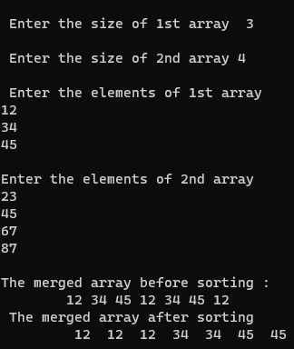

**43. All Operations of String.**

1. **strlen**: This function returns the length of a string.
2. **strcpy**: This function copies one string to another.
3. **strcat**: This function concatenates two strings.
4. **strcmp**: This function compares two strings and returns an integer based on the result of the comparison.
5. **strchr**: This function searches for a particular character in a string and returns a pointer to the first occurrence of the character.
6. **strstr**: This function searches for a particular substring within a string and returns a pointer to the first occurrence of the substring.
7. **strtok**: This function breaks a string into tokens based on a specified delimiter.
8. **strspn**: This function returns the length of the initial portion of a string that consists only of characters from a specified set.
9. **strpbrk**: This function searches a string for any of a set of characters and returns a pointer to the first occurrence of any of those characters.
10. **strcoll**: This function compares two strings using the current locale's collating sequence.

**44. C program to check whether a string is palindrome or not**

**without Compare Function of String.**

#include <stdio.h>

#include <string.h>

int main()

{

char str[100];

int i, length;

int flag = 0;

printf("Enter a string: ");

scanf("%s", str);

length = strlen(str);

for(i=0; i < length ;i++)

{

if(str[i] != str[length-i-1])

{

flag = 1;

break;

}

}

if (flag)

{

printf("%s is not a palindrome", str);

}

else

{

printf("%s is a palindrome", str);

}

return 0;

}



**45. C program to count frequency of each character in a string.**

#include <stdio.h>

#include <string.h>

int main()

{

char str[100];

int count[256] = {0};

int i;

printf("Enter a string: ");

scanf("%[^\n]s", str);

for (i = 0; str[i] != '\0'; i++)

{

count[str[i]]++;

}

for (i = 0; i < 256; i++)

{

if (count[i] > 0)

{

printf("'%c' occurs %d times\n", i, count[i]);

}

}

return 0;

}



**46. C program to find diameter, circumference and area of a circle**

**using functions.**

#include <stdio.h>

#include <math.h>

#define PI 3.14159

// Function prototypes

float diameter(float radius);

float circumference(float radius);

float area(float radius);

int main()

{

float radius, d, c, a;

printf("Enter the radius of the circle: ");

scanf("%f", &radius);

d = diameter(radius);

c = circumference(radius);

a = area(radius);

printf("Diameter: %.2f\n", d);

printf("Circumference: %.2f\n", c);

printf("Area: %.2f\n", a);

return 0;

}

float diameter(float radius)

{

return 2 * radius;

}

float circumference(float radius)

{

return 2 * PI * radius;

}

float area(float radius)

{

return PI * radius * radius;

}

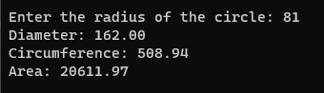

**47. C program to check prime, armstrong and perfect numbers**

**using functions.**

#include <stdio.h>

#include <math.h>

int is_prime(int n);

int is_armstrong(int n);

int is_perfect(int n);

int main()

{

int n, prime, armstrong, perfect;

printf("Enter a number: ");

scanf("%d", &n);

prime = is_prime(n);

armstrong = is_armstrong(n);

perfect = is_perfect(n);

if (prime)

{

printf("%d is a prime number\n", n);

}

else

{

printf("%d is not a prime number\n", n);

}

if (armstrong)

{

printf("%d is an Armstrong number\n", n);

}

else

{

printf("%d is not an Armstrong number\n", n);

}

if (perfect)

{

printf("%d is a perfect number\n", n);

}

else

{

printf("%d is not a perfect number\n", n);

}

return 0;

}

int is_prime(int n)

{

int i;

if (n <= 1)

{

return 0;

}

for (i = 2; i <= sqrt(n); i++)

{

if (n % i == 0)

{

return 0;

}

}

return 1;

}

int is_armstrong(int n)

{

int original, rem, result = 0, digits = 0;

original = n;

// Count the number of digits

while (original != 0)

{

original /= 10;

digits++;

}

original = n;

// Check if the number is an Armstrong number

while (original != 0)

{

rem = original % 10;

result += pow(rem, digits);

original /= 10;

}

return (n == result);

}

int is_perfect(int n)

{

int i, sum = 0;

for (i = 1; i < n; i++)

{

if (n % i == 0)

{

sum += i;

}

}

return (n == sum);

}

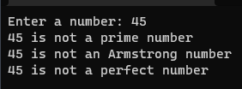

**48. C program to add two number using pointers.**

#include <stdio.h>

int main()

{

int a, b, sum;

int *pa, *pb;

printf("Enter two numbers: ");

scanf("%d %d", &a, &b);

pa = &a;

pb = &b;

sum = *pa + *pb;

printf("Sum = %d\n", sum);

return 0;

}

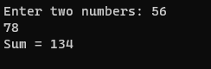

**49. Swap 2 numbers using Call by Value AND Call by reference.**

#include <stdio.h>

void swap_by_value(int x, int y);

void swap_by_reference(int *x, int *y);

int main()

{

int a, b;

printf("Enter two numbers: ");

scanf("%d %d", &a, &b);

printf("Before swapping (call by value): a = %d, b = %d\n", a, b);

swap_by_value(a, b);

printf("After swapping (call by value): a = %d, b = %d\n", a, b);

printf("Before swapping (call by reference): a = %d, b = %d\n", a, b);

swap_by_reference(&a, &b);

printf("After swapping (call by reference): a = %d, b = %d\n", a, b);

return 0;

}

void swap_by_value(int x, int y)

{

int temp;

temp = x;

x = y;

y = temp;

}

void swap_by_reference(int *x, int *y)

{

int temp;

temp = *x;

*x = *y;

*y = temp;

}

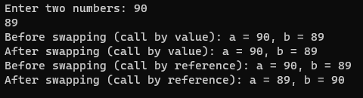

**50. C program to copy an array to another array AND reverse an**

**array using pointers.**  
#include <stdio.h>

void printArray(int arr[], int size);

int main()

{

int source_arr[MAX_SIZE], dest_arr[MAX_SIZE];

int size, i;

int *source_ptr = source_arr; // Pointer to source_arr

int *dest_ptr = dest_arr; // Pointer to dest_arr

int *end_ptr;

printf("Enter size of array: ");

scanf("%d", &size);

printf("Enter elements in array: ");

for (i = 0; i < size; i++)

{

scanf("%d", (source_ptr + i));

}

end_ptr = &source_arr[size - 1];

printf("\nSource array before copying: ");

printArray(source_arr, size);

printf("\nDestination array before copying: ");

printArray(dest_arr, size);

while(source_ptr <= end_ptr)

{

*dest_ptr = *source_ptr;

// Increment source_ptr and dest_ptr

source_ptr++;

dest_ptr++;

}

printf("\n\nSource array after copying: ");

printArray(source_arr, size);

printf("\nDestination array after copying: ");

printArray(dest_arr, size);

return 0;

}

void printArray(int *arr, int size)

{

int i;

for (i = 0; i < size; i++)

{

printf("%d, ", *(arr + i));

}

}

***PATTERNS***

**1. NUMBER PATTERN 1**

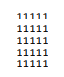#include <stdio.h>

int main()

{

int i, j, N;

printf("Enter number of rows: ");

scanf("%d", &N);

for(i=1; i<=N; i++)

{

for(j=1; j<=N; j++)

{

printf("*");

}

printf("\n");

}

return 0;

}

**2 RIGHT TRIANGLE**

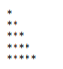

#include <stdio.h>

int main()

{

int i, j, n;

printf("Enter value of n: ");

scanf("%d", &n);

for(i=1; i<=n; i++)

{

for(j=1; j<=i; j++)

{

printf("*");

}

printf("\n");

}

return 0;

}

**3 MIRRORED RIGHT**



#include <stdio.h>

int main()

{

int i, j, rows;

printf("Enter number of rows: ");

scanf("%d", &rows);

for(i=1; i<=rows; i++)

{

for(j=i; j<rows; j++)

{

printf(" ");

}

for(j=1; j<=i; j++)

{

printf("*");

}

printf("\n");

}

return 0;

}

**4 PYRAMIDAL**

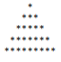

#include <stdio.h>

int main()

{

int i, j, rows;

printf("Enter number of rows : ");

scanf("%d", &rows);

for(i=1; i<=rows; i++)

{

for(j=i; j<rows; j++)

{

printf(" ");

}

for(j=1; j<=(2*i-1); j++)

{

printf("*");

}

printf("\n");

}

return 0;

}

**5 SQUARE 1**

#include <stdio.h>

int main()

{

int rows, cols, i, j;

printf("Enter number of rows: ");

scanf("%d", &rows);

printf("Enter number of columns: ");

scanf("%d", &cols);

for(i=1; i<=rows; i++)

{

for(j=1; j<=cols; j++)

{

printf("1");

}

printf("\n");

}

return 0;

}